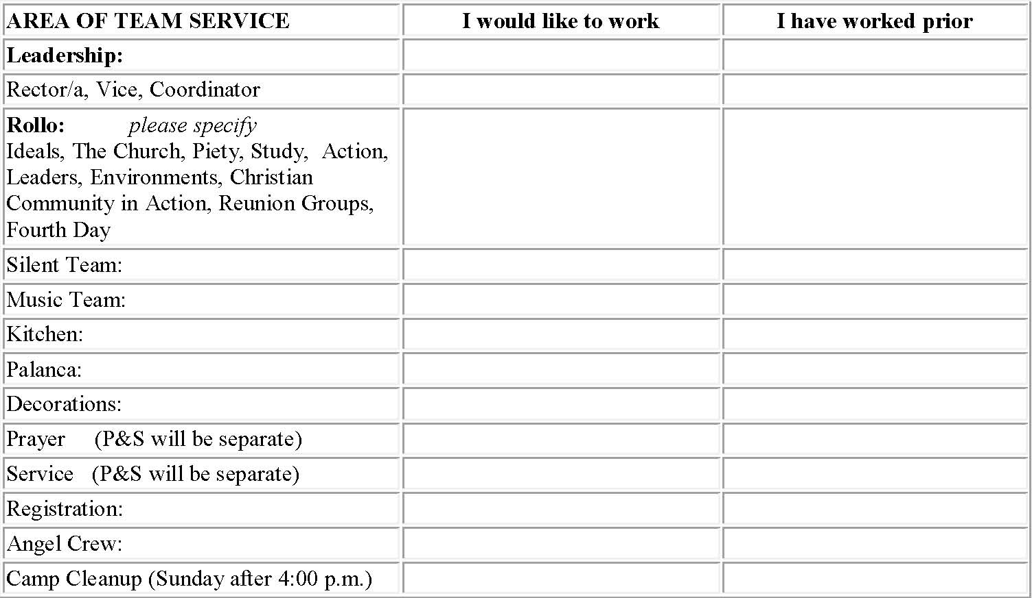
BIG SKY TRES DIAS TEAM APPLICATION
NAME: __________________________________________________________________________________

ADDRESS: _______________________________________________________________________________
PHONE: (Home) _________________ (Work) _______________ (E-mail) ___________________________
I attend church regularly at: _______________________
I attended a similar weekend at: _________________________ I attend a regular grouping? _______________________ I attend Ultreyas/Secuelas? _____________________________
TEAM MEETINGS: Please check the web site for further details on team meetings.
I cannot serve on site, but could help supply food for the weekend: ____________________________________
*Upon signing this application, I am aware that I have made a commitment to attend ALL of the appropriate and applicable team meetings. THE COST OF THE WEEKEND IS $85.00 PER PERSON. Please pay at the time you turn in your application or apply for a “scholarship” by contacting a member of the secretariat.
Signature: _____________________________________________Date: _______________________

