***Big Sky Tres Dias***

***Packet***

|  |  |
| --- | --- |
| ***Men's Weekend***  **May 17-20, 2012 Camp Kiwanis Havre, MT   *Adam Jeperson Rector   Vice-Rector Brad Shepherd*** | ***Women's Weekend***  **April  24 - April 27, 2012 Ursuline Centre 2300 Central Avenue Great Falls , MT 59401  406 452-8585 *Mandy Nitz  Rectora 7210 1st  St W Havre, MT 59501  (406)265-4816***  ***Vice-Rectora Melanie Watson*** |

SPONSOR GUIDELINES AND SPECIFIC NORMS

FOR CANDIDATE SELECTION

CANDIDATE MUST:

1. Be baptized.
2. Be a responsible and mature adult.
3. Have a Christian background.
4. Be returning to an environment where the Fourth Day is available to the candidate.
5. Be endorsed by a Pastor or leader of a recognized Christian Church. It is important to recognize the weekend experience is not for everyone. The person suffering from mental or spiritual anguish, emotional distress, or personal crisis may do well to consider a waiting period. The opinion of the candidate’s pastor or advisor is essential and may prevent serious complications during the weekend. The purpose of TRES DIAS is to develop Christian service, and should not be regarded as a form of crisis therapy.

SPONSOR RESPONSIBILITIES:

1. Have the candidate attend a group reunion or gathering with you.
2. Drive or arrange transportation to and from the weekend for the candidate.
3. Help arrange things so the candidate can devote full attention to the weekend. They should not be distracted with worries about duties and obligations.
4. Attend the TRES DIAS Weekend closing ceremony.
5. Arrange PALANCA to arrive from family and close friends.
6. Follow-up to assure that the candidate has found a place in a reunion group and gathering.
7. Encourage the candidate to Servant Ministry, particularly in penetrating other environments and sponsoring other candidates to a TRES DIAS Weekend.
8. Acquaint the candidate with the general form of the weekend and what to expect in general terms.
9. Your candidate should be advised of the monetary cost of the weekend, $75.00 per person, and the payment options. If need be, the TRES DIAS of MT Secretariat may provide a scholarship for your candidate. Contact the Rector or Rectora for further information. Or sometimes a friend or group may underwrite a candidate.
10. Return the completed Candidate Application, Sponsor Form and sealed Clergy Report to the pre-registration address.
11. PRAY FOR YOUR CANDIDATE DURING THE WEEKEND AND THE FOURTH DAY!

SPONSORS SHOULD BE LIVING THE FOURTH DAY!

If you have any questions regarding your sponsorship, please consult with one of the TRES DIAS Weekend leaders or Weekend spiritual leaders.

I HAVE READ ALL OF THE ABOVE AND HAVE PRAYED ABOUT SPONSORING THIS CANDIDATE. I WILL PRAY FOR THIS PERSON DURING THE COMING YEAR. I JOYFULLY ACCEPT SPONSORSHIP OF THIS CANDIDATE.

SIGNED: _______________________________________________ DATE: _______________

**2012 BIG SKY TRES DIAS TEAM APPLICATION   
Men’s Weekend May 17-20, 2012 Camp Kiwanis, Havre, MT**

**Women’s Weekend Apr  24 – April 27, 2012 Ursuline Centre, Great Falls, MT**

NAME: __________________________________________________________________________________ (Last) (First) (Middle) ADDRESS: _______________________________________________________________________________

(Street or Box #) (City) (State) (Zip) PHONE: (Home) _________________ (Work) _______________ (E-mail) ___________________________ I attend church regularly at: _______________________ I attended a similar weekend at: _________________________ I attend a regular grouping? _______________________ I attend Ultreyas/Secuelas? _____________________________

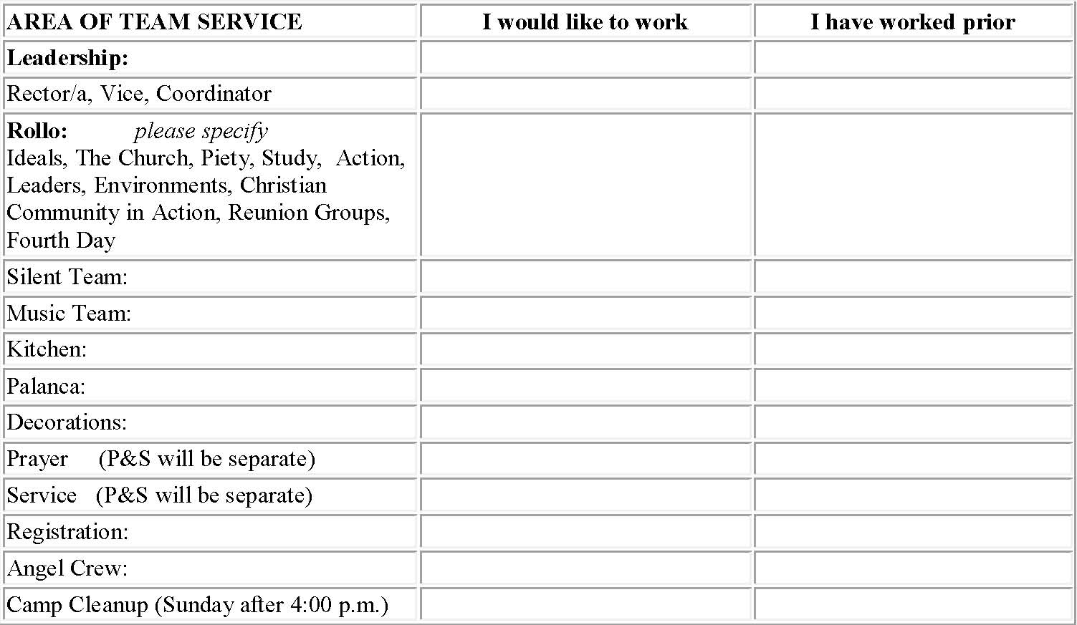

**TEAM MEETINGS**: Please check the web site for further details on team meetings.

I cannot serve on site, but could help supply food for the weekend: ____________________________________

*\*Upon signing this application, I am aware that I have made a commitment to attend ALL of the appropriate and applicable team meetings. THE COST OF THE WEEKEND IS $85.00 PER PERSON. Please pay at the time you turn in your application or apply for a “scholarship” by contacting a member of the secretariat.*

Signature: _____________________________________________Date: _______________________

**Mail this form to:  
MEN’S WEEKEND – Adam Jeperson, Helena, MT 59602  
WOMEN’S WEEKEND – Mandy Nitz, *7210 1st  St W, Havre, MT 59501  (406)265-4816***

TRES DIAS CLERGY REPORT

**2010 BIG SKY TRES DIAS TEAM APPLICATION   
Men’s Weekend May 13-16, 2010 Camp Kiwanis, Havre, MT**

**Women’s Weekend Apr  29-2, 2010 Ursuline Centre, Great Falls, MT**

**PLEASE PUT THIS REPORT IN A SEALED ENVELOPE WITH THE CANDIDATE’S NAME ON IT. RETURN IT TO THE CANDIDATE AS SOON AS POSSIBLE.**

It is important to recognize that the Tres Dias experience is not for everyone. The person suffering from mental or spiritual anguish, emotional duress or personal crisis may do well to consider a waiting period. The opinion of the Candidate’s Pastor or Priest is essential and may prevent serious complications during the Tres Dias weekend. The purpose of the weekend is to develop Christian service and should not be recognized as a form of crisis therapy.

Name of Candidate: ____________________________________________________________

Address: _____________________________________________________________________

(Street) (City) (State) (Zip)

Parish or Congregation: __________________________________________________________

Attendance? Negligent ____________ Fair ____________ Conscientious ________________

Does this person have any physical needs that would require special attention? ______________

If “yes”, please elaborate if possible: ________________________________________________

Marital Status? _____________________ Family Status? _____________________________

Comments: ____________________________________________________________________

Are you aware of any serious personal, emotional or mental problems this person might have?

If “yes”, please elaborate if possible: ________________________________________________

______________________________________________________________________________

Would you recommend this person for an intensive three-day encounter with Christ, called the Tres Dias weekend? _____________________________________________________________

Have you had other members of your congregation attend a weekend? _____________________

How could this person best serve Christ and your congregation following this experience? ____

Other helpful comments: _________________________________________________________

Signature of Pastor or Priest: ___________________________________ Date: _____________

**PLEASE PRAY FOR THIS PERSON!**

**BIG SKY TRES DIAS CANDIDATE APPLICATION**

Please note: All information is confidential. The information requested is vital to the review of the Candidates. COMPLETE ALL SPACES! Return to your sponsor.

Name: _________________________________________________________________________ (Last) (First) (Middle) (Nickname)

Address: _________________________________________________________________________

(Street) (City) (State) Zip)

Phone: ___________________ Work: _____________ Cell: ____________________

Email: ________________ Age: _____ Birthdate: _________ Male:__Female:_

Occupation: ______________________Employer: ____________________________

Marital Status:___________

# of children_______ Ages:___________________________

Name/Spouse: _______________________________ Has spouse attended a similar weekend? _________________

When: ______________________ Where: __________________________________

Do you have any physical condition or illness that may require special consideration? _____________________________

Do you require a special diet or medication: ___________________________________________________

Have you ever applied to a similar weekend before? ___________ When______________ Where__________________

(Please use back if additional space is required)

Church affiliation:_______________________Demonmination:________________

Clergy:_________________________________________________________________

(Name) (Address) (Phone) (Email)

Are you baptized:______Date:_______________Location:____________________

List spiritual/religious activities in which you participate: ______________________________________________________

List civic organization in which you participate: ______________________________________________________________

Reason for Attending: _________________________________________________________________________________________________________________________________________________________________________________________

HAVE YOU ASKED YOUR CLERGY TO PRAY FOR YOU? _________

Applicant’signature:____________________________________________________

Sponsor__________________________________________________________________

(Name) (Address) (Phone) (Email)

**Sample Palanca Letter**

DATE____________________

Dear Family and Friends of _________________________,

__________________ will be spending a very special weekend of _______________, at Tres Dias (formerly called Cursillo). It is a weekend of learning about the fundamentals of Christian Living. Tres Dias is also a time of renewal, love and sharing in fellowship.

This weekend is unique in that it contains many special surprises. One of the surprises we call “encouragement”. This encouragement comes in the form of letters, cards and notes sent from _______________’s family and friends. The letters will be given at certain times during the three days **he/she** is at the Tres Dias camp in _______________________________________.

As ______________’s sponsor, I am asking you to support **her/him** by writing one or more letters. The subjects for each of the three days of the Tres Dias are FAITH, LOVE, and HOPE. Here are a few ideas that might help you get started:

* A shared experience
* An expression of Love
* A special prayer
* A favorite poem

I know that **she/he** will be so pleased to hear from you, that you took the time to write **her/him**. These letters are a surprise, so please don’t mention them until after the weekend.

Please put ___________’s full name (and not yours) on the outside of the envelope and seal it. Send it (or them) in another envelope to me by _(a week before the weekend)________. If you write more than one letter, please also number them “day 1”, “day2”, “day 3” or “faith”, “hope” “love”, so **she/he** does not receive them all on the same day.

Sponsor Name

Sponsor Address

Sponsor Address

If you have any questions, please contact me at ____(your phone number)____ evenings, or __(phone number)_____________ daytime office or anytime on cell, ___________________. Again, thank you for adding special meaning to the weekend. May the grace and peace of our Lord Jesus Christ be always with you.